Our Programs
  IGCSE  Our IGCSE programme prepares you for university and beyond — Pearson Edexcel in Nay Pyi Taw, with core and optional subjects, exam preparation, and experienced teachers.  View Details |   Pre-IGCSE  One-year foundation at MNEA (Pearson Edexcel Approved Centre): weekday classes, March intake, pathway to IGCSE — fees from K 5,900,000 with installment & promotion options.  View Details |   Global Primary Learning Program  Build a strong primary foundation through English, Mathematics, Science, Computing, and supportive enrichment subjects.  View Details |   English 4 Skills (PEIC, UK)  Weekend PEIC pathway: free Level Test, June–December 2026 intake (140h + 10 bonus hours), levels Pre-A1–B2 with monthly fees from K 195,000 — exam in Nay Pyi Taw.  View Details
  Chinese Language Program  Learn Chinese with structured lessons in communication, characters, pronunciation, and cultural understanding.  View Details |   Business & Management  2026 online intake: Business English Level 1 — four skills, evening classes (Myanmar Time), practical workplace modules from greetings to company profiles. Programme fee K 790,000.  View Details | 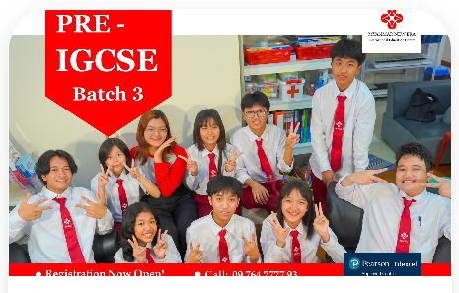  Coding & Robotics  Hands-on coding and robotics programme for school-age learners with project-based lessons in logic, programming, and practical problem solving.  View Details |   Online Class  Business English - Level 1 (Online Class), 2026 intake: Tue/Wed/Thu at 7:00 pm - 8:30 pm via live Zoom sessions. Practical workplace modules with online registration and payment.  View Details
Program Features
Small Class Size : Small classes allow teachers to give more attention to every student.
Interactive Learning : Students actively participate in speaking and discussion activities.
Experienced Teachers : Learn from qualified and experienced English instructors.
International Curriculum : Use globally recognized learning materials.
Certificate After Completion : Students receive a certificate after successfully completing the course.

Who Should Join This Program
Students who want to improve English skills
People preparing for international exams
Professionals who want better communication skills
Anyone who wants to study English systematically

Learning Outcomes
After completing the course, students will be able to:
- Speak English with more confidence
- Improve listening and comprehension
- Read and understand English texts better
- Write clearly and effectively

Not Sure About Your English Level?
Take our FREE Placement Test to discover the best course for your level.
60-minute test Instant result
Take Free Placement Test

